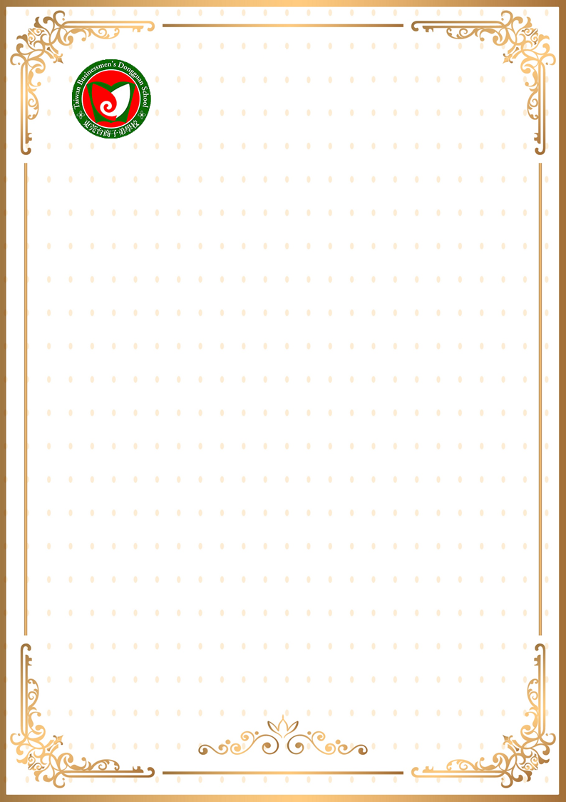
Type in Bold with Times New Roman Font, Size 14
TBDS Reading Contest (Junior)

Reader: Class: 70X No: 01 Name: 李XX
Book Title:
Author :

